Name : Anjali Hingu

PRN : 2020033800098732

Assignment 2

Fibonacci series

class Assign1

{

static void Main(String[] args){

//fibonacci series

// factorial of large number

int a = 0, b = 1, c = 0;

Console.WriteLine("Enter Number:");

int len = Convert.ToInt32(Console.ReadLine());

Console.Write(""+b+"");

for (int i = 1; i < len; ++i)

{

c= a + b;

Console.Write(c+"");

a= b;

b= c;

}

}

}

Output:



Factorial

class Assign2

{

static void Main(String[] args){

int f=1,i;

Console.WriteLine("Enter the number you want to find factorial for:");

int n = Convert.ToInt32(Console.ReadLine());

for(i=1;i<=n;i++){

f=f*i;

}

Console.WriteLine(f);

}

}

Output:

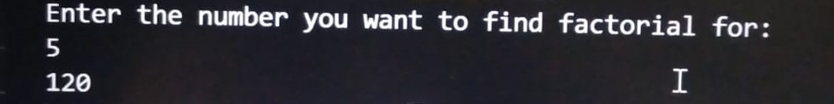

Permutation

using System;

public class Permutation

{

    static void permute(String s, String ans)

    {

        if (s.Length == 0)

        {

            Console.Write(ans + " ");

            return;

        }

        for (int i = 0; i < s.Length; i++)

        {

            char ch = s[i];

            String left_substr = s.Substring(0, i);

            String right_substr = s.Substring(i + 1);

            String rest = left_substr + right_substr;

            permute(rest, ans + ch);

        }

    }

    public static void Main(String[] args)

    {

        String s;

        String ans = "";

        Console.Write("Enter the string : ");

        s = Console.ReadLine();

        Console.Write("\n All possible strings are : ");

        permute(s, ans);

    }

}

|  |  |
| --- | --- |
|  |  |

Output:

